LEICESTER IS UK’s CLASSIC CAR CAPITAL
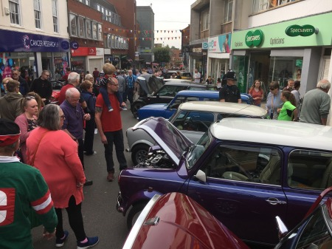  Leicester and its surrounding towns have the highest concentration of classic car owners in the UK, according to figures released today by ClassicLine Insurance  • Motor mad Midlands is hotspot for classic car enthusiasts.  • Leicester is UK centre for lovers of desirable older cars.  • Midland’s classic car ‘Bermuda Triangle’ also includes Coventry and Birmingham.  Forget the money-rich commuter belt of the south-east or quintessentially English Cotswolds as new research reveals that Leicester - more famous for crisps - is the UK centre for classic car enthusiasts!  Indeed, the findings show that the LE Leicester postcode has well over a third more classic car insurance policy holders with ClassicLine Insurance than anywhere else in the country – an even more surprising result than the city’s shock Premiership win.  Further analysis shows that the car manufacturing heartland of the Midlands has a ‘Bermuda Triangle’ of classic car hotspots which also includes Coventry and Birmingham, showing that locals are in tune with the region’s rich motoring heritage.  “It’s great to hear that people in the Midlands love their four-wheel friends more than anywhere else in the country, especially as the area has a strong automotive history,” says Ian Fray, MD of ClassicLine Insurance.  Away from the motor mad Midlands, southern postcodes including Guildford, Tunbridge Wells and Reading, are also high on the list of ClassicLine Insurance policy holders – although none in the south are higher placed than Coventry in third position.  Fray adds: “What could be better than taking a trip to the Peak District, motoring along Leicester’s leafy lanes or enjoying Warwickshire’s winding roads than behind the wheel of a classic car. This certainly seems be what Midlander’s are doing in their droves.”  For more information about ClassicLine Insurance, including policies for classic cars, custom cars and kit cars, visit www.classiclineinsurance.co.uk | .
  Position | Postcode |  | Number of ClassicLine Insurance policy holders (indexed to show 100 as base figure and other figures in ratio to 100)
  1 | LE (Leicester) |  | 100
  2 | B (Birmingham) |  | 65
  3 | CV (Coventry) |  | 65
  4 | GU (Guildford) |  | 56
  5 | CM (Chelmsford) |  | 52
  6 | RG (Reading) |  | 51
  7 | TN (Tunbridge Wells) |  | 50
  8 | NG (Nottingham) |  | 47
  9 | S (London) |  | 45
  10 | RH (Redhill) |  | 44

